Steps for ODBC installation:

Step 1:

/usr/bin/ruby -e "$(curl -fsSL https://raw.githubusercontent.com/Homebrew/install/master/install)"

brew tap microsoft/mssql-release https://github.com/Microsoft/homebrew-mssql-release

brew update

brew install --no-sandbox msodbcsql@13.1.9.2 [mssql-tools@14.0.6.0](mailto:mssql-tools@14.0.6.0)

Issue the above command on terminal.

Step 2:

odbcinst -d -q

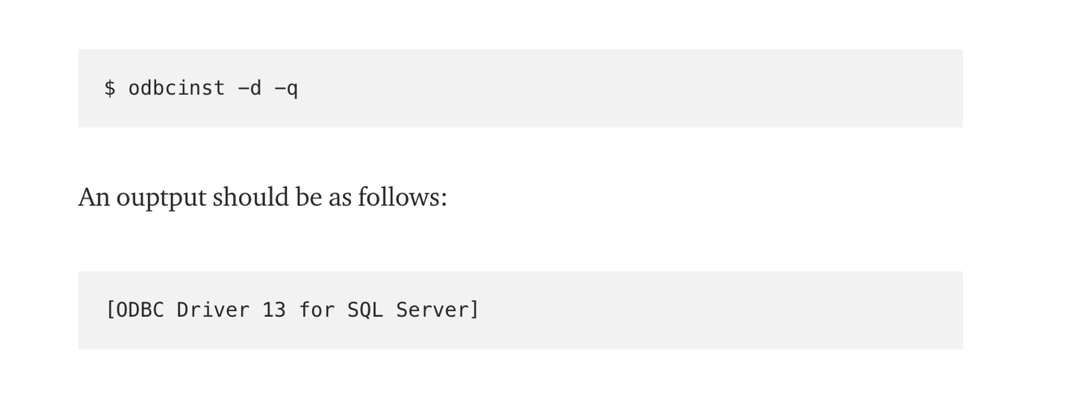

Step 3:

If you don’t get the desired output in Step 2

On terminal:

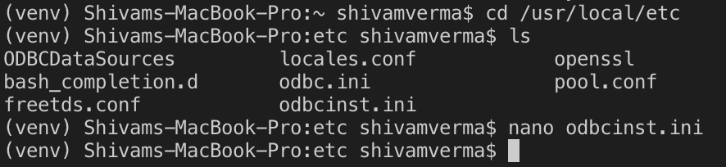

Commands:

cd /usr/local/etc

ls

nano odbcinst.ini

Paste the following in odbcinst.ini

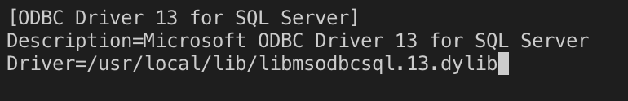

Step 4:

Same as step 2

